Logging into and using Glow
How does my child get access to Glow?
Your child has been given access by the school via a unique login using a secure username and password. Your child’s teacher will give your child their username and password..
This gives your child access to information and resources suitable for them.
Go to: https://sts.platform.rmunify.com/Account/SignIn/glow
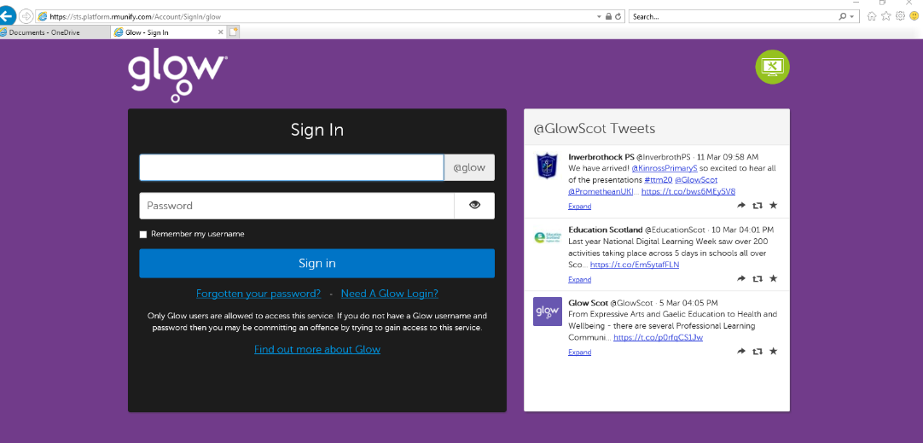

Enter your child’s username (this is usually their school computer log in) i.e SA14SmithJ into the first box.
Enter your child’s password into the second box and click ‘Sign In’.
You may them be prompted to accept the Glow usage policy.
After signing in you will be taken to the Glow Launch Pad which will look similar to the picture below.
From here your child can access Teams (to communicate with their teacher), Accelerated Reader and other educational areas. (Note that your child’s class may have different tiles than those in the picture below)
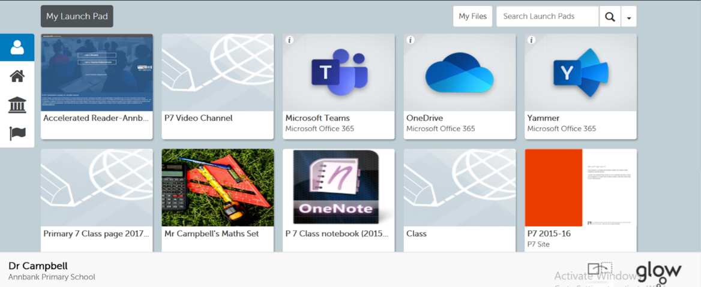

Microsoft Teams
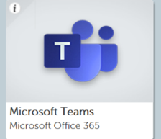
Microsoft Teams will be used as the main method of communication between the class teacher and your child.

It is here that the class teacher will post links to activities, online videos, provide instructions etc. Your child can also post questions and communicate with their teacher through Teams. All messages posted in the class Teams group are seen by all members of that class.
The main Teams screen looks like this:
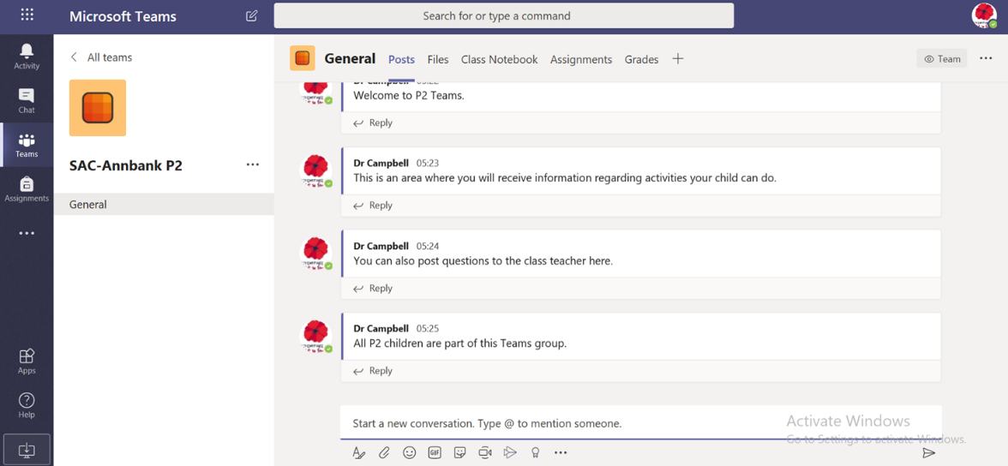

Each time you go into Teams you will be taken to the ‘Posts’ page. This is where messages will be posted, and your child can communicate with their teacher. Clicking the paperclip icon at the bottom of this page will allow your child to submit any completed work, or photos of work, by attaching it to their post,
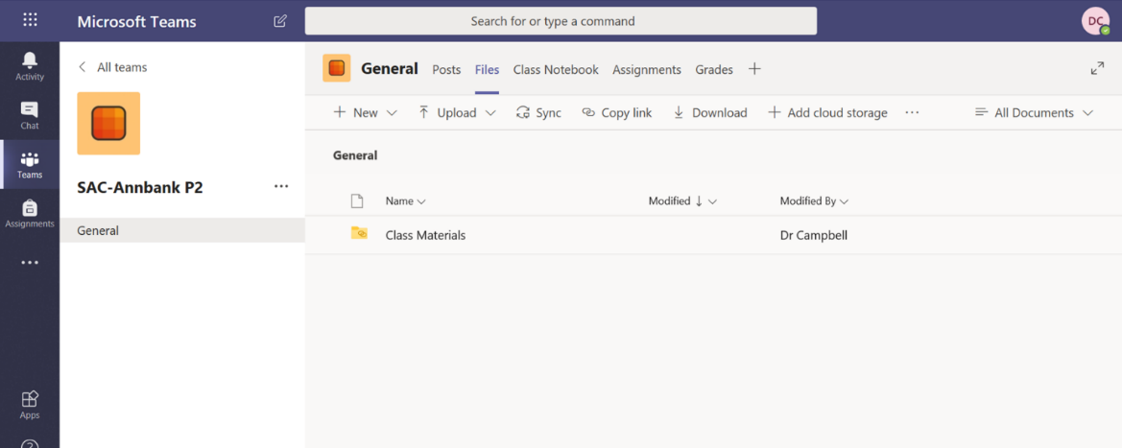

The files tab is where any documents or sheets will be posted for your child to access.

Email access
Your child can access email using the ‘Mail’ tile.
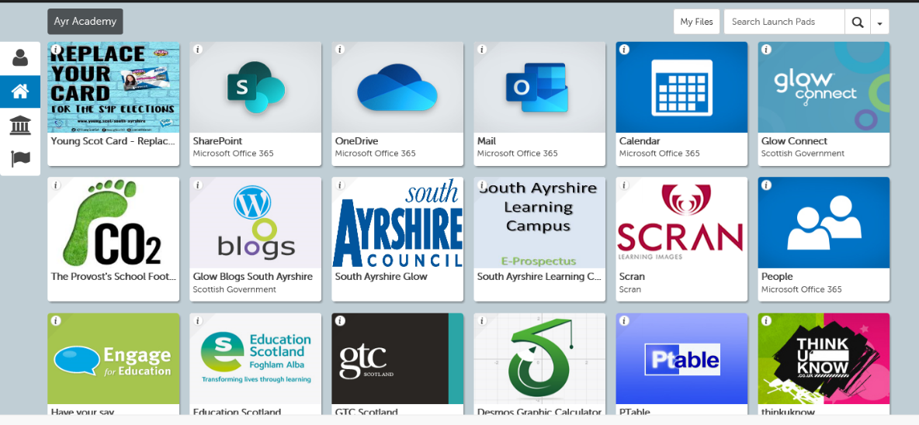

You may then be promoted to set a Language and Time Zone. Please select ‘English’ and then ‘Dublin, Edinburgh, Lisbon, London’ time zone. Click Save to continue.
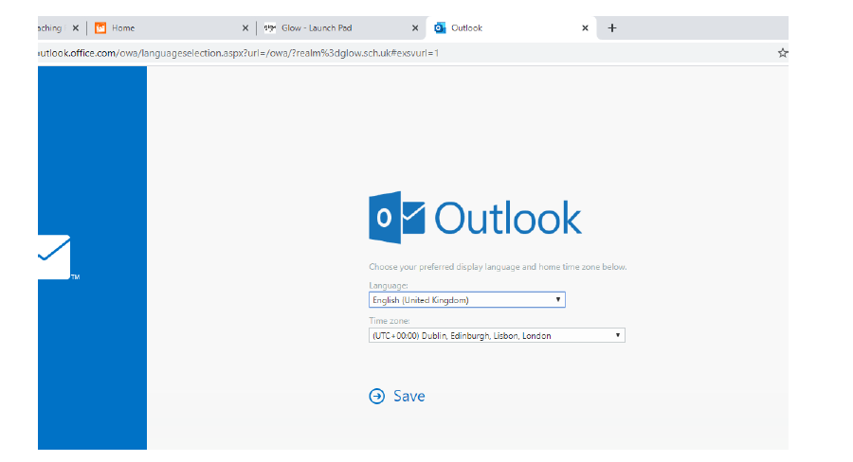
You will then be taken to your child’s inbox which will look something like this:

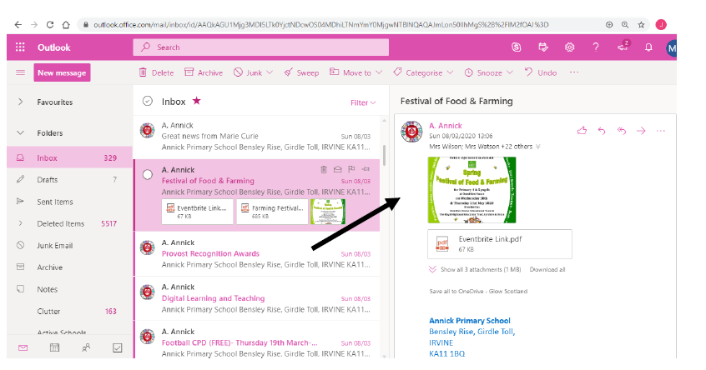
Emails will appear here which, when opened, will appear on the right hand side.

Mobile Devices and Apps
If your child uses a tablet or mobile device, there are a range of apps that can be used to access the various tools in Glow. These apps are available for both Apple and Android devices, and are provided free with your child’s Glow account.
The following apps are particularly useful:
- Teams
- Word
- PowerPoint
- Outlook
When you install and run any of these apps your child will be asked to log in with an email address. The address that should be used is their Glow email address which will be given to your child. This email address is in the following format:
SA14SmithJ@glow.sch.uk
The first part of this email address (shown in bold above) is your child’s South Ayrshire username that they use to log on to the computers in school.
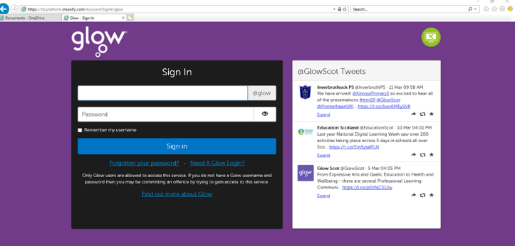
When this is entered, the internet browser will open on the device and will go to the purple Glow login page. Here your child should log in with their Glow password. This links the app to their Glow account.

Once this has been done the first time, there should be no need to log in each time, as the app will remember the Glow account details.
Should you have difficulty getting the Glow apps working on a mobile device, post a message in your child’s Class Teams discussion and we will try to resolve the issue.

