**Annbank Primary School**

**Welcome back to Term 2 in P2**

Here’s what we will be learning in class this term!

[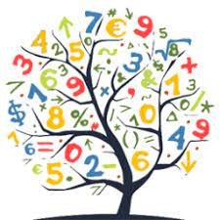](https://www.google.co.uk/imgres?imgurl=https://pbs.twimg.com/profile_images/690482639237726208/bifPZpsl_400x400.png&imgrefurl=https://twitter.com/phsmathematics&tbnid=qYeI3mvVK1Bg3M&vet=10CAMQxiAoAGoXChMI4LbNk76i6wIVAAAAAB0AAAAAEAc..i&docid=wf8K82avjngi2M&w=256&h=256&itg=1&q=numeracy&hl=en-GB&safe=active&ved=0CAMQxiAoAGoXChMI4LbNk76i6wIVAAAAAB0AAAAAEAc)

**Literacy**

**Spelling:** This term we are looking at the following sounds (ck, oa, ie, ee, or, oo, ou, oi) and continuing to cover Fry’s First 100 words (our common words). Weekly homework tasks that include spelling and reading are posted in ‘Teams’.

**Reading:** We will have a new reading book each week and a different one for homework each week (Bug Club online). We will also have time for reading for enjoyment and will be read a range of stories during Story Time.

**Writing:** This term we are continuing to use the Talk for Writing approach to develop our ability to write imaginative stories. We will be looking at the book ‘Man on the Moon’ and writing stories set in space.

[](https://www.google.co.uk/imgres?imgurl=https://img.icons8.com/bubbles/2x/information.png&imgrefurl=https://icons8.com/icons/set/information&tbnid=fElcQPg5SOuR2M&vet=12ahUKEwjb_uPywaLrAhVBZRoKHUMkCWIQMyhkegUIARDHAQ..i&docid=5RtjHa4ZVL99oM&w=200&h=200&q=information&hl=en-GB&safe=active&ved=2ahUKEwjb_uPywaLrAhVBZRoKHUMkCWIQMyhkegUIARDHAQ)[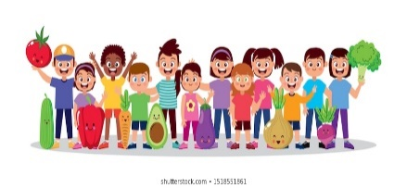](https://www.google.co.uk/url?sa=i&url=https://www.shutterstock.com/search/child%2Bhealthy%2Beating?searchterm%3Dhoarsely%26clear_recent_searches%3D1%26ref_context%3Dkeyword&psig=AOvVaw0gOAMOkTIQp_l2h9Id0vlf&ust=1597763091622000&source=images&cd=vfe&ved=0CAIQjRxqFwoTCPjr8L3BousCFQAAAAAdAAAAABAF)[](https://www.google.co.uk/url?sa=i&url=https://www.vectorstock.com/royalty-free-vector/back-to-school-icon-book-and-pencil-vector-8051116&psig=AOvVaw01Nj7ijqFBiMvv41IPiHYD&ust=1597758247629000&source=images&cd=vfe&ved=0CAIQjRxqFwoTCOjckrivousCFQAAAAAdAAAAABAE)

**Other Information**

Our teacher is Miss Ferguson. We have morning break at **10:15am**. We eat our lunch in the dinner hall at **11:50am** and go out to play at **12:15pm**. We can be dropped off at school at any time between **8.45am and 9am** and we finish the school day at **2:55pm.** We wash our hands throughout the day, especially before and after break times. We also use the hand sanitiser stations at each of the entrance doors. We will be learning outside as often as we can so please make sure we are provided with appropriate clothing and sun protection as necessary.

Throughout this term there will be a number of focus weeks where we will be taking part in a range of activities. These focus

weeks will include: Dyslexia Awareness, Anti-bullying and

Scottish Book Week.

**Health and Wellbeing**

**IDL – Man on the Moon:** This term is a busy

term with Halloween and Christmas so we are only doing a mini topic based on the book ‘Man on the Moon’. We will be learning all about the moon and what it is like to work in space.

**IDL – COP 26:** Our whole school topic for this term is COP 26. Linked to our Global Goals from last term we are looking at how we can make a difference to the world.

**P.E.:** This term we will be covering Football, Gymnastics and Hockey. Our P.E. days will still be **Tuesdays** and **Wednesdays.** We will also take part in the daily mile each day and other active activities throughout the week such as **outdoor learning on Thursday afternoons**.

**Numeracy**

**Time:** This term we will be learning to tell the time using

analogue and digital clocks as well as the days of the week and months of the year. This links to our mini topic this term – Man on the Moon.

**Money:** We will be learning to recognise coins and notes as well as use money to pay for items in a play setting. This also links to our mini topic.

**Number Talks:** We are using the Number Talks programme to practise our counting, number recognition and number processing skills in weekly Number Talks lessons.