Literacy & English |  | Expressive Arts |  | Social Studies
LIT 1-02a/04a/07a  ENG1-31a  LIT1-28a/  29a  LIT1-26a  LIT1-23a/  24a  LIT 1-25a  LIT1-14a /15a  ENG 1-30a | MTV-class consultation (see think wonder), explanation game.  Imaginative – story set in Egypt or diary entry.  Functional writing: fact sheet eg Tutankhamun, Gods, Nile.  Select ideas to write a newspaper report – Howard Carter’s discovery of Tut’s tomb.  Instructions – mummification.  Present writing in legible and attractive way.  Use non-fiction and internet to research aspects of Ancient Egypt, make notes and write info in logical sequence, to interest reader.  Personal writing – Trip | EXA1-02a  EXA1-03a  EXA 1-04a  EXA1-08a  EXA1-17a | Observational drawing of Egyptian artefact.  Egypt sunset painting/collage.  Paint Tutankhamun’s funeral mask.  Write name in hieroglyphics.  Make papyrus  Discuss and express thoughts and feelings about paintings.  Make an Egyptian necklace  Learn Egyptian song and dance. | SOC1-01a/3a  SOC1-15a  SOC1-02a  SOC1-04a  SOC1-05a  SOC 1-12b  SOC1-06a | Finding evidence from different sources eg books, photographs and artefacts about the past. Online session  Facts about pyramids. Importance of Gods.  Beliefs – mummification.  Importance of River Nile – fact sheet.  Compare climate and how it affects living things – camels, cactus  Find out about Tutankhamun and Howard Carter.
Health & Wellbeing |  | Interdisciplinary Topic  Ancient Egyptians  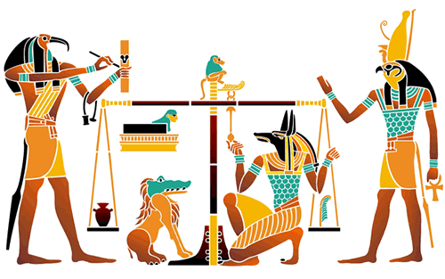  P3 April – June 2022  Articles 12, 13, 14, 28, 29 |  | RME
HWB1-19a  HWB1-11a  HWB1-14a  HWB 1-20a | Sharing our learning.  Working as a team.  Working with a partner.  Valuing ideas of others.  Daily life of Egyptians – work, different roles/jobs. |  |  | RME 1-05a/7a/9c | Egyptian beliefs/gods. Creation story.
 |  |  |  | Ethos and Life of School
 |  |  |  | HWB  1-05a  1-08a  1-12a  1-19a  21a/22a  1-25a | Jubilee Week  Read Woke  Eco Week  After School Clubs  Sports Day  RRSA  Committee’s – Health/Wellbeing
Maths |  | ICT/Technology |  | Personal Achievement
MTH1-16b  MNU1-10b  MTH1-12a | Make 3D pyramid from net.  Egyptian calendar and seasons.  Crack hieroglyph code.  Egyptian number system. | TCH1-09a, 10a, 12a, 13a  TCH1-02a/  3b  TCH 1-01a | Problem solving when constructing models – eg pyramid, shadouf,  Use internet to find facts – search engine terms.  Mummy maker ICT game.  Online games and quizzes. | HWB  1-11a  1-21a/22a  1-12a  EXA1-01a | Class champion  Sport’s Day  Competitions
Discrete Teaching
HWB:  1-01a/3a/5a/  7a/8a/9a/10a  12a/13a/16a/  20a/44b/45b  HWB1-21a,22a23a,24a  LIT1-07a  LIT1-08a/18a  LIT 1-11a  LIT1-13a  LIT1-16a/17a  LIT 1-21a  LIT 1-22a/23a  ENG 1-12a  MLAN 1-01a/b  MLAN 1-02a/b  MLAN 1-05a/b  MLAN 1-10a  MTH1-16a/b  MNU1-03a  MNU1-07a/b  MNU1-11a  MNU1-22a | HWB:  Read Woke  IcePack.  PE – fitness, athletics  Literacy  Reading: Storyworld.  Spelling: silent ‘e’  igh, eigh, common words  Comprehension: Blooms Buttons, Nelson Comp. Grammar: Proper Nouns, Pronouns, Sentences, Commas.  French  Numbers to 12. Age, colour  Numeracy and Maths  Multiplication/Division x4, x8  (Revision of x2, x5, x10)  Area  Time, calendars  Chance and  Probability

