Discrete Teaching
Literacy & English |  | Maths |  | Health & Wellbeing
LIT 1-02a  LIT 1-04a  LIT 1-05a  LIT 1-09a  LIT 1-11a  LIT 1-13a  LIT 1-14a  LIT 1-18a  LLIT 1-20a  LIT 1-24a  LIT 1-25a  LIT 1-26a | Talking and Listening  Contribute to class discussions Share thoughts about Viking life  Listen and watch videos about Viking Life and Gods/Goddesses  Participate in a tour of Vikingar  Reading  Explore non-fiction texts  Skim and scan to find relevant information  Read for information  Explore the difference between fact and opinion  Writing  Create a Viking warning poster  Create an information poster about Viking life  Create a comic strip of a Viking adventure  Write an imaginative Viking Story/Saga | MNU 1-11a  MTH 1-19a | Research number of miles travelled on longships  Demonstrate symmetry in shield/longships designs/models | HWB 1/2-05a  HWB 1/2-09a  HWB 1/2-10a  HWB 1/2-11a  HWB 1/2-14a | RRS  Recognition board  Collaborative working  Self & Peer assessment  Mental and Emotional Wellbeing
Social Studies |  | Interdisciplinary Topic-  Vikings  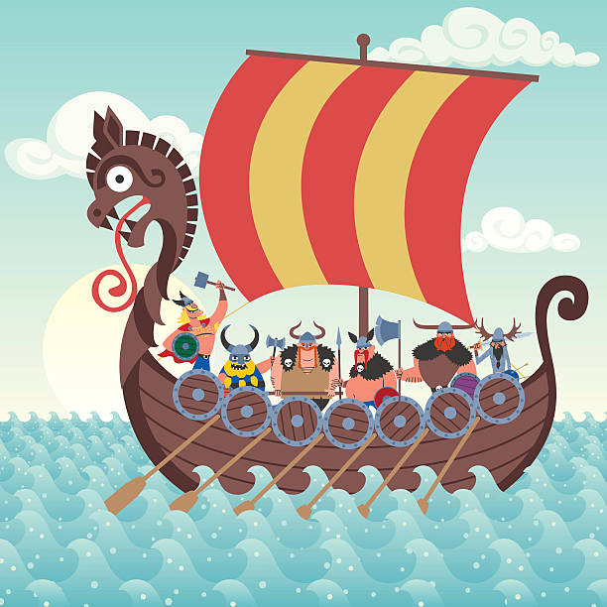 |  | ICT/Technologies
SOC 1-01a  SOC 1-02a  SOC 1-03a  SOC 1-04a  SOC 1-06a  SOC 1-14a | Read texts about Viking age  Explore impact Vikings had on Britain  Compare daily lives of the past with my own  Explore Up Helly Aa tradition  Learn about Vikings Gods and Goddesses  Explore the Battle of Largs  Investigate actions of famous Vikings  Explore routes Vikings travelled to Scotland using maps |  |  | TCH 1-01a/  TCH 1-02a  TCH 1-09a |  | Use internet to research about the Battle of Largs/Up Helly Aa  Design and test a longship model
 |  |  |  | Personal Achievement
 |  |  |  | HWB 1/2-11a  HWB 1/2-12a | Target Setting  Over & Above
Expressive Arts |  | Sciences |  | Ethos and Life of the School
EXA 1-02a  EXA 1-03a  EXA 1-04a  EXA 1-06a  EXA 1-14a  EXA 1-18a | Art  Using various media, create artwork of a shield  Make a model of a longship  Create a Viking broach  Create a Viking chant | SCN 1-15a | Design and test a longship model (water experiment) | See whole school planners for topics, Es and Os and coverage | Sports Day  Queen’s Jubilee  School Committees  Class Champion  Read Woke Programme  After School Clubs  Eco Week

LIT 1-01a  LIT 1-02a  ENG 1-03a  LIT 1-04a  LIT 1-07a  LIT 1-11a  LIT 1-14a  ENG 1-12a  LIT 1-13a  ENG 1-17a  ENG 1-19a  LIT 1-23a  LIT 1-20a LIT 1-26a  ENG 1-31a  LIT 1-21a  LIT 1-22a  LIT 1-23a  LIT 1-24a  MNU 1-03a  MNU 1-10a/b  MTH 1-15a/b  MTH 1-18a  MNU 1-22a  HWB 1-06a  HWB 1-09a  HWB 1-33a  HWB 1-21a  HWB 1-22a  HWB 1-23a  HWB 1-25a  HWB 1-24a/27a  HWB 1-25a  MLAN 1-01b  MLAN 1-02a  MLAN 1-10a  SCN 1-04a/09a  SCN 1-08a  SCN 1-12a  SCN 1-20a  TCH 1-01a | Literacy  Spelling, VCOP, Grammar  Listening and Talking  Reading for enjoyment, engaging with others, following instructions  Fluency, expression and choice of words  Identifying the purpose of a text  Show understanding of texts  Reading  Reading for enjoyment  Understanding, analysing and evaluating text  Tools for Reading  Tricky words  Using context clues  Independent reading  Paired reading  Blooms Taxonomy  Exploring Read Woke books  Writing  Organising and using information  Functional writing  Playscript writing  Tools for writing  Use different strategies to spell tricky words  Use a dictionary and thesaurus  Punctuate using commas, speech marks, apostrophes  Proof-read texts, edit work Sentence openers, similes and adjective phrases, alliteration, paragraphs  Past and present tenses  Maths  Multiplication and Division  Addition and Subtractions  Time  Algebraic problems  Orienteering  Uncertainty and chance  HWB  Expressing and managing emotions  Exercising rights and accepting responsibilities  Ready, respectful, safe  The Human Body  Volleyball  Summer Games  Athletics  French  Listening for information  Talking with others  Using knowledge of language  Science  Engery/Circuits  Forces: Magnets  Body systems  Developing awareness of science in the world  Technologies  Using ICT to enhance learning  (Ipads)

