**Annbank Primary School**

[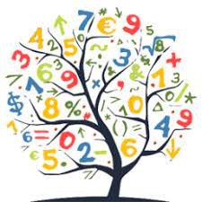](https://www.google.co.uk/imgres?imgurl=https://pbs.twimg.com/profile_images/690482639237726208/bifPZpsl_400x400.png&imgrefurl=https://twitter.com/phsmathematics&tbnid=qYeI3mvVK1Bg3M&vet=10CAMQxiAoAGoXChMI4LbNk76i6wIVAAAAAB0AAAAAEAc..i&docid=wf8K82avjngi2M&w=256&h=256&itg=1&q=numeracy&hl=en-GB&safe=active&ved=0CAMQxiAoAGoXChMI4LbNk76i6wIVAAAAAB0AAAAAEAc)[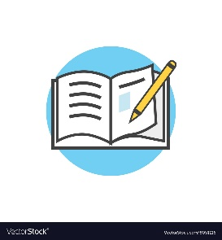](https://www.google.co.uk/url?sa=i&url=https://www.vectorstock.com/royalty-free-vector/back-to-school-icon-book-and-pencil-vector-8051116&psig=AOvVaw01Nj7ijqFBiMvv41IPiHYD&ust=1597758247629000&source=images&cd=vfe&ved=0CAIQjRxqFwoTCOjckrivousCFQAAAAAdAAAAABAE)**Welcome back to Term 1 in P5**

Here’s what we will be learning in class this term!

**Numeracy**

This term we are focusing on Number and Number Processes, as well as beginning to develop our understanding of measurement.

Primary 5 will be exploring whole numbers up to 10,000 and decimal fractions up to one place, with a focus on reading, writing and ordering. We will also develop our understanding of Addition and Subtraction including decimals and begin to develop our knowledge of measurement, focusing on length and perimeter.

We will continue to further develop our skills of concrete, pictorial and abstract using various strategies such as counting on, counting back, partitioning and friendly numbers and also daily Number Talk lessons.

**Literacy**

As a class we are exploring the novel The Iron Man by Ted Hughes. We will be focusing on reading aloud, projecting our voice, reading with expression and pausing with punctuation. Whilst exploring The Iron Man we will develop our comprehension skills with a focus on justifying our answers. This term our focus in writing will be to develop our VCOP skills and we will work on both imaginative writing and poetry.

We will continue to explore spelling rules and sounds with a weekly focus. We are going to develop our understanding of words and use them in context.

[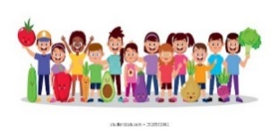](https://www.google.co.uk/url?sa=i&url=https://www.shutterstock.com/search/child%2Bhealthy%2Beating?searchterm%3Dhoarsely%26clear_recent_searches%3D1%26ref_context%3Dkeyword&psig=AOvVaw0gOAMOkTIQp_l2h9Id0vlf&ust=1597763091622000&source=images&cd=vfe&ved=0CAIQjRxqFwoTCPjr8L3BousCFQAAAAAdAAAAABAF)[](https://www.google.co.uk/imgres?imgurl=https://img.icons8.com/bubbles/2x/information.png&imgrefurl=https://icons8.com/icons/set/information&tbnid=fElcQPg5SOuR2M&vet=12ahUKEwjb_uPywaLrAhVBZRoKHUMkCWIQMyhkegUIARDHAQ..i&docid=5RtjHa4ZVL99oM&w=200&h=200&q=information&hl=en-GB&safe=active&ved=2ahUKEwjb_uPywaLrAhVBZRoKHUMkCWIQMyhkegUIARDHAQ)

**Other Information**

This term we are continuing with soft start from 8.45am every morning and we finish the school day at 3.00pm. We wash our hands throughout the day, especially before and after break times. We also use the hand sanitiser stations at each of the entrance doors. Our break is between 10.30am and 10.50am and Lunch is from 12.30pm until 1.20pm. Hot lunches are available and are brought to our classroom.

Primary 5 will also be taking part and completing their Level 1 Bikeability, learning life skills and road safety. More information will follow with regards this.

**Adventure Centre for Education is coming to Annbank Primary School Term 1!**

A.C.E. is an outdoor learning organisation, specialising in delivering outdoor learning pursuits to children of all ages and this term all pupils in

Primary 1-7 will participate in Forest School activities and all pupils in

Primary 5-7 will experience Water Sports.

**IDL & Other Curriculum Areas**

For Health and Wellbeing, we will focus on developing our knowledge and understanding of having a healthy mind and body. We will cover a range of experiences and topics which will allow children to discuss their feelings and explore positive relationships. We will focus on being Ready, Respectful and Safe in and around the school.

PE lessons will take place Tuesday and Wednesday and will be outdoors, so please ensure children come to school with suitable clothing for all weathers.

Primary 5 will explore what Harvest Time means to our local community and the world in which we live. This will link in with our IDL topic – Global Goals, where we will explore these goals and how they are an action plan to help respect children’s rights everywhere.