Home Learning Grid - Strike Days Tuesday 26th – Thursday 28th September
Guidance for Home Learning
As you are aware, the school will be closed, unless the strikes are called off, to pupils and staff for 3 days next week.
Below are learning tasks for your child to complete each day the school is closed. These learning tasks are available in paper copy, are on your child’s class TEAMS page and are also on the school website.
We would encourage you to use the activities and websites provided and read any books your child has brought home from school.
Teaching staff will be working from home and will be available through TEAMS during the school working hours.
 | Literacy | Numeracy | Other
Tuesday 26th September | Write a book review about your favourite book – follow the template provided  Read for Pleasure – no time limit on this! | Use Topmarks to improve your fluency in times tables and division facts.  Have a go at counting up in multiples. How far can you get? Measure the time it takes you for each!  Could you do it faster the next time? | Within your family home, how can you reduce your carbon footprint?  Create an information poster displaying your ideas!
Wednesday 27th September | Test your spelling, grammar and punctuation accuracy  KS2 English free game - Grammar, spelling and punctuation for primary school pupils - Crystal Explorers - BBC Bitesize | Complete the fractions challenge worksheets  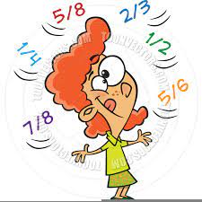 | Have fun with topic words and complete the climate change word search  *Ask permission first*  Using the Home Energy Check tool, find out how efficient your home is and identify where improvements can be made.  Home Energy Check tool · Home Energy Scotland
Thursday 28th September | Write a recipe for your favourite food – follow the template provided! | Keep it Real – Come up with 10 real life contexts for using fractions. | Art - Free Drawing Activity: Impress your teacher with your drawing skills, draw anything that you like using anything you like!

