**Annbank Primary School**

**Term 2 in P6**

Here’s what we will be learning in class this term!

[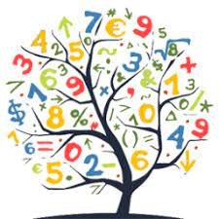](https://www.google.co.uk/imgres?imgurl=https://pbs.twimg.com/profile_images/690482639237726208/bifPZpsl_400x400.png&imgrefurl=https://twitter.com/phsmathematics&tbnid=qYeI3mvVK1Bg3M&vet=10CAMQxiAoAGoXChMI4LbNk76i6wIVAAAAAB0AAAAAEAc..i&docid=wf8K82avjngi2M&w=256&h=256&itg=1&q=numeracy&hl=en-GB&safe=active&ved=0CAMQxiAoAGoXChMI4LbNk76i6wIVAAAAAB0AAAAAEAc)[](https://www.google.co.uk/url?sa=i&url=https://www.vectorstock.com/royalty-free-vector/back-to-school-icon-book-and-pencil-vector-8051116&psig=AOvVaw01Nj7ijqFBiMvv41IPiHYD&ust=1597758247629000&source=images&cd=vfe&ved=0CAIQjRxqFwoTCOjckrivousCFQAAAAAdAAAAABAE)

**Literacy**   
This term we continue and finish our book study titled “Holes” by

Louis Sacher. This book study will help all pupils to develop their comprehension skills and use of grammar and punctuation. Our writing will be developed through the novel study also. Pupils will continue to develop spelling patterns through a range of active and written spelling activities. We will have a particular focus on handwriting and cursive writing this term, and we have time each day in class to read our own books independently for enjoyment. We will visit the library every Tuesday with Graham.

**Numeracy**

In Number we are working with numbers up to 100,000.

We will be working with Part-Part-Whole questions to help reinforce our addition and subtraction skills, focussing on partitioning,

counting on, counting back and transformation. We will then move on to learning about division and multiplication problems and the methods used to solve these such as sharing, grouping, repeated addition and compensation. We will also examine order of operations, and factors/primes. In Beyond Number Mr McGillivray will look at symmetry and angles.

[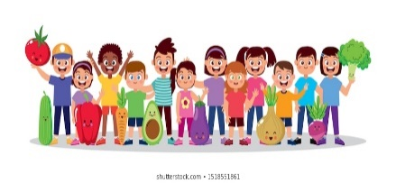](https://www.google.co.uk/url?sa=i&url=https://www.shutterstock.com/search/child%2Bhealthy%2Beating?searchterm%3Dhoarsely%26clear_recent_searches%3D1%26ref_context%3Dkeyword&psig=AOvVaw0gOAMOkTIQp_l2h9Id0vlf&ust=1597763091622000&source=images&cd=vfe&ved=0CAIQjRxqFwoTCPjr8L3BousCFQAAAAAdAAAAABAF)

**Health and Wellbeing**

This term our Health & Wellbeing will focus on

Kindness and respect towards one another.

Mr McGillivray and Mrs Kerr will help promote this in our classroom.

We will also promote good H&WB through our Inter-Disciplinary Learning (IDL) this term with is focussing on COP26 and how we can help the climate crisis. Through this topic we will look at how small changes we all make can make a big difference in the world we live in for future generations.

We will also have Scottish Book Week and Anti-Bullying week this term.

We will have PE three times weekly outdoors, on Mondays with Mr McGillivray, Tuesdays with Eilidh our Active Schools Coordinator, and on a Friday with Mrs Kerr/Mrs Hogarth.

This term’s PE will focus on hockey (Mrs Hogarth), netball (Mrs Kerr), handball (Eilidh) and tennis (Mr McGillivray).

**Other Information**

Our teachers are Mr McGillivray who is in class on a Monday, and Mrs Kerr who will teach us the rest of the week. This term we will continue to have our lunch in the classroom. We are continuing our soft starts in the mornings this term and can join our class any time from 8.45am and 9am. Our school day finishes at 3pm. Regular hand washing will take place in class, and we also use hand sanitiser as we enter the school after break times. We will be learning outside as often as we can.

Spelling words are uploaded to Teams weekly. Teams will continued be to be used to communicate with pupils, please ensure you are able to access Teams so you don’t miss any information sent.

**EXCITING NEWS ---** P6 will have their forest school days with ACE Adventure Centre of Education in November, on Friday 12th November and Friday 26th November. Details will be sent out nearer these dates.