Discrete Teaching
LIT 2-16a  ENG 2-17a  ENG 2-19a  LIT 2-20a  LIT 2-21a  LIT 2-22a  LIT 2-23a  LIT 2-24a  LIT 2-26a  ENG 2-27a  LIT 2-28a  ENG 2-31a  MLAN 2-01a  MLAN 2-01b  MLAN 2-01c  MNU 2-11abc  MNU 2-12a  MNU 2-13a  MNU 2-15a  MNU 2-20ab  MNU 2-21a  MNU 2-22a  HWB 2-15a  HWB 2-16a  HWB 2-17a  HWB 2-18a  HWB 2-19a  HWB 2-20a  HWB 2-30a  HWB 2-32a  HWB 2-33a  HWB 2-21a  HWB 2-22a  TCH 2-01a | Literacy  Reading  Reading Comprehension  Reading for Purpose  Blooms Questioning  Literacy Circles  Grammar (Gary)  Writing  Writers; Craft  Poetry  Persuasive Writing  Spelling,  VCOP & Grammar  Handwriting  Modern Languages  French (Gary)  Maths  Measure (Gary)  Maths Impact  Patterns & Relationships  Expressions & Equations  Data Analysis  Chance & Uncertainty  (& revision)  HWB  The Human Body  Assessing & Managing Risk  Keeping Safe/Em. Situations  Travelling Safely  Skills for Future  Healthy Eating  Nutrition  Hygiene & Wellbeing  Rugby  Sports Leadership  Technology (Gary)  Podcasting – recording, editing, manipulating and broadcasting sound using various software suites.
Literacy & English |  | Maths |  | Health & Wellbeing
LIT 2-02a  LIT 2-08a  LIT 2-11a  LIT 2-13a  LIT 2-14a  LIT 2-15a  LIT 2-17a  LIT 2-26a  ENG 2-27a  LIT 2-24a  LIT 2-25a  LIT 2-26a  LIT 2-27a  LIT 2-28a | Talking and Listening  Discuss music videos, examining the main idea conveyed  Reading  Personal Research/Note Taking  Reading for Specific Purpose  Using Strategies & Resources  Reading for information  Reading for enjoyment  Lit Circles with WW2 based novels  Comprehension based on WW@ texts  Author’s themes  VIPER – Boy in Striped Pyjamas  Writing  Child Evacuee Letters home  Propaganda Posters  Organising Information/Notes | MNU 2-11abc | Scale – Building Anderson shelters | HWB 2-01a  HWB 2-05a  HWB 2-06A  HWB 2-08a  HWB 2-10a  HWB 2-11a  HWB 2-13a  HWB 2-14a  HWB 2-19a  HWB 2-20a  HWB 2-39a  HWB 2-41a  HWB 2-43a |  | Rights Respecting Schools:  RRS  Collaborating with Peers  Discuss injustice & prejudice against others  Protection of children - evacuees  RRSA Links –6,7,8,9,10,11
Social Studies |  | Interdisciplinary Topic  WW2  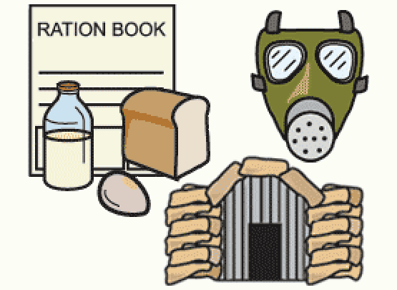 |  | ICT/Technologies
SOC 2-01a  SOC 2-02a  SOC 2-03a  SOC 2-04a  SOC 2-16a | World mapping activities,  Countries involved  Timelines of Key events  Holocaust & Ann Frank  Clydebank Blitz  Air Raids – building Anderson shelters  Child Evacuees  Rationing  Women in War  VE Day |  |  | TCH 2-03a  TCH 2-04a  TCH 2-04b | Research activities related to Social Studies activities in next column.
 |  |  |  | Personal Achievement
 |  |  |  | HWB 2-06a  HWB 2-07a |  | Bikeability  Class Champion  Afterschool clubs
Expressive Arts |  | Sciences/RME |  | Ethos and Life of the School
EXA 2-01a  EXA 2-02a  EXA 2-03a  EXA 2-04a EXA 2-05a  EXA 2-16a | Propaganda Posters  Use of various media – charcoal, paint, oil pastels | RME 2-04abc  RME 2-05ab  RME 2-06abc  RME 2-07a  RME2-09abcd | Judaism – various aspects | HWB 2-09a  HWB 2-10a  HWB 2-11a  HWB 2-12a  HWB 2-13a  HWB 2-14a |  | Eco Week  Queens Jubilee Celebrations  Sports Day  Bump Up day/Transition  School Trip  History Alive class visit

