**Annbank Primary School**

[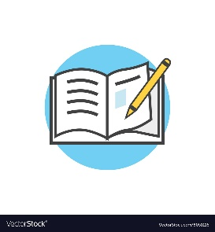](https://www.google.co.uk/url?sa=i&url=https://www.vectorstock.com/royalty-free-vector/back-to-school-icon-book-and-pencil-vector-8051116&psig=AOvVaw01Nj7ijqFBiMvv41IPiHYD&ust=1597758247629000&source=images&cd=vfe&ved=0CAIQjRxqFwoTCOjckrivousCFQAAAAAdAAAAABAE)**Welcome back to Term 4 in Primary 7**

[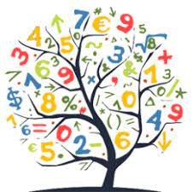](https://www.google.co.uk/imgres?imgurl=https://pbs.twimg.com/profile_images/690482639237726208/bifPZpsl_400x400.png&imgrefurl=https://twitter.com/phsmathematics&tbnid=qYeI3mvVK1Bg3M&vet=10CAMQxiAoAGoXChMI4LbNk76i6wIVAAAAAB0AAAAAEAc..i&docid=wf8K82avjngi2M&w=256&h=256&itg=1&q=numeracy&hl=en-GB&safe=active&ved=0CAMQxiAoAGoXChMI4LbNk76i6wIVAAAAAB0AAAAAEAc)Here’s what we will be learning in class this term!

**Literacy**

Throughout term 4, we will be completing a novel study of “The Elsewhere Emporium”. We will be exploring characters feelings, friendships and the impact this has. As part of our novel study, we will explore setting and language while using timelines to support our understanding. We will be uplevelling our discursive writing through use of PEEL paragraphs in preparation for secondary school.

During term 4, we will also be focusing on questioning through Bloom’s Taxonomy and a range of in depth comprehension approaches. We will continue to further our understanding of phonics, spelling rules and common/tricky words. Our writing focus will be to develop and consolidate our understanding of play scripts, discursive and informative writing.

**Numeracy**

Our focus will be on fractions, decimals and percentages throughout term 4. We will be looking at equivalent fractions and their simplest form. Primary 7 will also look at multiplying, dividing, adding and subtracting decimals with multiple digits. We will also focus on percentages of a quantity where pupils will develop their understanding using a calculator and without where they will use a range of strategies.

During this term, we will also consolidate our understanding of angles, chance and uncertainty, probability and budgeting using profit and loss.

[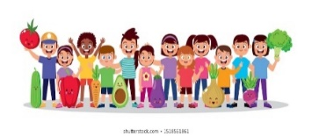](https://www.google.co.uk/url?sa=i&url=https://www.shutterstock.com/search/child%2Bhealthy%2Beating?searchterm%3Dhoarsely%26clear_recent_searches%3D1%26ref_context%3Dkeyword&psig=AOvVaw0gOAMOkTIQp_l2h9Id0vlf&ust=1597763091622000&source=images&cd=vfe&ved=0CAIQjRxqFwoTCPjr8L3BousCFQAAAAAdAAAAABAF)[](https://www.google.co.uk/imgres?imgurl=https://img.icons8.com/bubbles/2x/information.png&imgrefurl=https://icons8.com/icons/set/information&tbnid=fElcQPg5SOuR2M&vet=12ahUKEwjb_uPywaLrAhVBZRoKHUMkCWIQMyhkegUIARDHAQ..i&docid=5RtjHa4ZVL99oM&w=200&h=200&q=information&hl=en-GB&safe=active&ved=2ahUKEwjb_uPywaLrAhVBZRoKHUMkCWIQMyhkegUIARDHAQ)

**Other Information**

Primary 7 will be focusing on planning and delivering their P7 leavers service. We will have a focus on transition where we will have online and in person transition days at Ayr Academy (following Covid guidance and mitigations).

We will have a range of focus days which will be consistent throughout the school and involve the wider community where possible.

Mr Crookston will be delivering inputs for both PE and BMT. Be prepared for all weather conditions (details of dates to follow).

**IDL/Health and Wellbeing/Other Curricular Areas**

This term, we will have a focus on science. We will be covering areas from changes in substances to electricity, light and sound. We will also be covering the human body where we will look at a range of body systems. As part of this topic we will be explore human life and parenting.

Primary 7 will also be participating in Bikeability. We will focus on travel safety and emergency situations. As part of our Health and Wellbeing, we will also be focusing on some delicate subjects such as abuse, substance misuse and how to seek advice/help. Our campus officer from Ayr Academy will also assist these inputs.