2023 - 2024
Annbank Primary School & EYC School Improvement Plan
As a GOLD Accredited Rights Respecting School, we acknowledge the importance of Article 3 in all we do:
‘The best interests of the child must be a top priority in all actions concerning children.’

VISION
At Annbank Primary School and Early Years Centre we strive to provide a safe, stimulating learning environment where all children are motivated to reach their potential and are well equipped to meet the challenges of education, work and life in the 21st century. This is a welcoming, caring school where children and adults feel they contribute and are valued as individuals.
“A learning community’s well-being has a lot to do with the quality of relationships, cohesion, inter-dependence and belonging.”
VALUES
- Equality
- Truth/ honesty
- Respect
- Effort
- Inclusion

AIMS
In a positive, safe, caring environment at Annbank Primary and Early Years Centre we aim to:
- In Curriculum – provide a structured programme of education which takes account of National and Local Guidelines and which is matched to pupils’ age, aptitude and ability in such a way that each child realises his/her potential as fully as possible.
- In Attainment – support each child in achieving his/her potential.
- In Learning & Teaching – strive for the highest standards in learning & teaching.
- In Support for Pupils – provide support for each child according to their needs.
- In Ethos – work in partnership with pupils, staff and parents, other agencies and the community in an atmosphere where every person feels valued.
- In Resources – work to achieve best value in the use of all resources – human and material- to provide good, quality education.
- In Management, Leadership and Quality Assurance - through good quality assurance systems work to achieve good management, self-evaluation and educational development.

National Improvement Framework Priorities
Education Services Priorities
Children’s Service Plan
South Ayrshire Council Plan
HGIOS 4 Quality Indicators: 1.1 Self-Evaluation for Self-Improvement; 1.2 Leadership of Learning; 1.3 Leadership of Change; 2.2 Curriculum; 2.3 Learning, Teaching and Assessment; 2.4 Personalised Support; 3.2 Raising Attainment & Achievement
NIF Priorities: Improvement in attainment, particularly in Literacy and Numeracy. Closing the attainment gap between the most and least disadvantaged children and young people. Improvement in employability skills and sustained, positive school-leaver destinations for all young people
Target: To raise attainment for all in literacy and close the attainment gap by improving attainment
Outcomes | Measures | Intended Impact | Actual Impact
Increase 5% of all learners on track to achieve expected CFE level in literacy  % of learners on track to achieve expected level:  P1/P4/P7 literacy from 83% to 88%  Reading: 83% to 88%  Writing: 79% to 84%  L&T: 87% to 92%  Focus on P3 Reading 76%, P3 Writing 56%, P5 writing 79%  Increase 5% of all learners achieving 8 or more Communication and Language Early Years milestones focussing on skills progression in syllables, rhyme, alliteration and sound/letter recognition.  57% to 62% | ACEL level cohort tracking including December and June data uplifts  Learning conversations progress updates  Class observation feedback on teaching of literacy  Various data and Standardised assessments across P1-P7  Data from literacy interventions  Attendance (lates and absences) of targeted learners  Staff and Pupils Surveys  Milestone tracking- Sept/Oct and May/June data uplifts.  Interim completed December. | Increase number of targeted learners achieving CFE levels in literacy at P1, P4, P7  Identified attainment gap will decrease by 5%.  All staff are involved in cluster moderation of learning, teaching and assessment  All staff will have had the opportunity to engage with South Ayrshire Reads Programme and therefore will have improved knowledge of best practice in reading. (See Appendix 1)  All parents will have had the opportunity to engage with South Ayrshire Reads Programme and therefore will have improved knowledge and understanding of how their child learns to read. (See Appendix 1)  Highlighted the importance of accurate representation in literature  Progressive intervention programme designed and tailored to raise lowest achieving milestones.  Increase number of targeted learners achieving Early Level milestones in Literacy.  Identified attainment gap will decrease by 5%.  To ensure staff understanding on impact of pedagogical practices on raising attainment including – MTV, differentiation, outdoor learning, play based learning and others.  Engage staff across cluster in pedagogical practitioner enquiry.  All pupils are supported in the preparation for transitioning into secondary school through Ayr Academy transition programme
Lead Persons: Caroline Tonner DHT, Suzie Morton CT, Lauren Meikle CT
Timescales: By June 2024 (Including mid-year review)
Budget: PEF - School Assistants, EYP in P1, new reading schemes/reading books, author visits

HGIOS 4 Quality Indicators: 1.1 Self Evaluation for Self-Improvement; 1.2 Leadership of Learning; 1.3 Leadership of Change; 2.2 Curriculum; 2.3 Learning, Teaching and Assessment; 2.4 Personalised Support; 3.2 Raising Attainment & Achievement
NIF Priorities: Improvement in attainment, particularly in Literacy and Numeracy. Closing the attainment gap between the most and least disadvantaged children and young people. Improvement in employability skills and sustained, positive school-leaver destinations for all young people.
Target: To raise attainment for all in numeracy and close the attainment gap by improving attainment
Outcomes | Measures | Intended Impact | Actual Impact
Increase % of all learners on track to achieve expected CFE level in numeracy  % of learners on track to achieve expected level:  P1/P4/P7 Numeracy from 87.5% to 92.5%  Focus on P3 Numeracy 76%  Increase 5% of all learners achieving 8 or more Numeracy and Maths Early Years milestones focussing on skills progression in number recognition, touch counting, making quantities and dot patterns.  91% to 96% | ACEL level cohort tracking including December and June data uplifts  Learning conversations progress updates  Class observation feedback on teaching of numeracy  Various data and Standardised assessments across P1-P7  (GL, Number Sense, Early Level Assessments, Hodder, Headstart, Arithmetic, Problem Solving and Reasoning)  Pre and Post Positive Mathematical Mindset questionnaires  Data from numeracy-based interventions (5 Minute box, Catch-up Numeracy, Number Sense, Mathseeds, CPA)  Staff and Pupils Surveys  Milestone tracking- Sept/Oct and May/June data uplifts.  Interim completed December. | Increase number of targeted learners achieving CFE levels in numeracy P1, P4, P7  Identified attainment gap decrease by 5%  All staff are involved in cluster moderation of learning, teaching and assessment  All staff are involved in ‘Building Thinking Classrooms’ CLPL  Almost all staff deliver mathematics and numeracy lessons using ‘Building Thinking Classrooms’ pedagogy  Almost all children will score as having a growth mindset using data from post Positive Mathematical questionnaires  To ensure staff understanding on impact of pedagogical practices on raising attainment including – MTV, differentiation, outdoor  All pupils are supported in the preparation for transitioning into secondary school through Ayr Academy transition programme  Progressive intervention programme designed and tailored to raise lowest achieving milestones.  Increase number of targeted learners achieving Early Level milestones in Numeracy.  Identified attainment gap will decrease by 5%.
Lead Persons: Carolyn Hall PT, Gill McKenzie CT
Timescales: By June 2024 (Including mid-year review)
Budget: PEF - School Assistants, EYP in P1, IT equipment

HGIOS 4 Quality Indicators: 1.1 Self Evaluation for Self-Improvement; 1.2 Leadership of Learning; 1.3 Leadership of Change; 2.2 Curriculum; 2.3 Learning, Teaching and Assessment; 2.4 Personalised Support; 3.2 Raising Attainment & Achievement
NIF Priorities: Closing the attainment gap between the most and least disadvantaged children and young people; Improvement in children and young people's health and wellbeing. Improvement in employability skills and sustained, positive school-leaver destinations for all young people. Placing human rights of every child and young person at the centre of education.
To develop Children’s Rights Agenda across the cluster
To reach next level of Rights Respecting School Accreditation
Continue to improve children and young people’s HWB
Outcomes | Measures | Intended Impact | Actual Impact
Children’s Rights Agenda developed across the cluster  Renew Rights Respecting Accreditation at Gold.  All stakeholders have an awareness of UNCRC Bill – Incorporation (Scotland) Bill  Children empowered and inspired to think about and share their views.  To increase the percentage of children at P1, P4 and P7 achieving expected CfE levels in HWB from 95% to 98% (whole school)  Ave school attendance is currently 90.5%; increase to 95%  Enhance nurture provision across the school and develop nurture approaches for all.  Support inclusion of all learners within school.  Provide environments that are supportive and inclusive.  Continue to improve children and young people’s HWB  Strengthen schools approaches to 3.1 and 2.4 to impact positively on pupils HWB, attainment and achievement  Enhance creative ways to explore our rights for our youngest learners in a gentle, age-appropriate way.  Parental knowledge of SHANARRI increased. | Staff learning conversations progress updates  Class observation feedback on pupil voice  Wellbeing indicators (through wellbeing webs)  Attendance (lates and absences) of targeted learners  Staff, parent and Pupils Surveys  Good practice feedback following ‘Looking outward’ staff visits  Observations of ‘SHANARRI Shed’ (Pre and post adaptations)  Pupil Voice Feedback  SHANARRI Champion Role Learning Journal | Cluster project –  OUTRight – Speak out on Children’s Rights – Children, pupils and staff will be inspired to speak out for change through cluster campaign  Empower pupil voice through improved relationships within cluster RRS groups (pupil and staff)  Empowered and inspire children to think about and share their views  All staff are involved in cluster moderation through context of children’s rights and social justice  Cluster project –  Students and staff will be encouraged and challenged to read books outside of their social norm, broadening their understanding and engagement with social justice issues. Highlight the importance of accurate representation in literature  All children (P1/P4/P7) produce evidence to demonstrate progressive skills development (planned assessment evidence)  Increase number of children reporting wellbeing indicators as 10 – 90% across all indicators.  Use information and data - attendance increased by 5%.  All pupils are supported in the preparation for transitioning into secondary school through Ayr Academy transition programme  Our youngest learners are supported in their journey of rights and their importance recognised, by increasing recognition in memorable ways.  Raised parental awareness which will feed directly into Personal Plans, benefitting children through shared understanding.
Lead Persons: Karen Butchart HT, Lorraine Hogarth CT
Timescales: June 2024 (and mid-year review)
Budget: PEF - School Assistants, Welfare Officer (2 days), EYP in P1, Nurture resources,

Appendix 1
South Ayrshire Service Plan Priority:
- Closing the poverty-related attainment gap by improving attainment in literacy
SAR Strategic Plan Priority:
To raise attainment in literacy and close the reading attainment gap between the most and least disadvantaged children and young people in South Ayrshire
ALL SOUTH AYRSHIRE SCHOOLS 2023-2024
SAR Strategic Aim | Actions | Intended Impact | Resources | SAR Lead | Completion  Date
To develop confident and skilled readers in South Ayrshire with a lifelong love of reading and the confidence to access all aspects of education, culture and society  To support and develop all education staff in South Ayrshire to implement best practice through a culture of shared knowledge, collaboration and enquiry | By June 2023 all schools will have an identified Reading Leader | The values, vision and aims of  South Ayrshire Reads  is consistent and clear to all stakeholders | All reading leaders can join a dedicated MS Team to ensure access to information, local/regional/national messages and resources and, opportunities to collaborate. |  | June 2023
 | By June 2023 all clusters will have an identified SAR link person to direct enquiries / requests to. |  | South Ayrshire Reads strategy document and MS Team |  | June 2023
 | By end of August 2023 ALL education staff, parents, children and young people will be introduced to the strategic vision of (SAR)the South Ayrshire Reads initiative. |  | SAR Video link will be provided, and time allocated on August Inservice days to share with all school staff.  (Please share with all pupils during the first few weeks of term and share the video link on your school social media channels) |  | August 2023
 | By April 2024 ALL education staff will have had the opportunity to attend an online South Ayrshire Reads Engagement session |  | Multiple dates will be available throughout the session and will be promoted through Reading Leaders Network, Education Update and, SAR Twitter feed |  | April 2024
 | By April 2024 ALL parents, carers and partners will have had the opportunity to attend an online South Ayrshire Reads Engagement session |  | Multiple dates will be available throughout the session and will be promoted through Reading Leaders Network, Education Update and, SAR Twitter feed |  | April 2024
 | By September 2023 ALL primary education staff will have engaged in initial science of reading training (Sept Twilight) and follow-up training (TBC) |  | Multiple dates will be available throughout the session and will be promoted through Reading Leaders Network, Education Update and, SAR Twitter feed |  | April 2024
 | By February 2024 ALL school assistants will have had the opportunity to attend in-person Supporting Children with Reading training |  | Training will take place on both October 2023 and February 2024 Inservice days |  | Oct 2023  Feb 2024
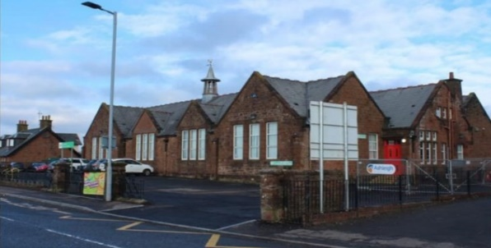
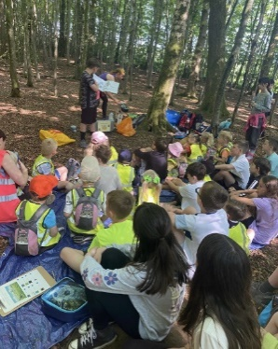
UNCRC Articles  - Article 3  Adults must do what’s best for me  - Article 6  I should be supported to live and grow  - Article 12  I have the right to be listened to and taken seriously.  - Article 13  I have the right to find out and share information.  - Article 15  I have the right to meet with friends and to join groups.  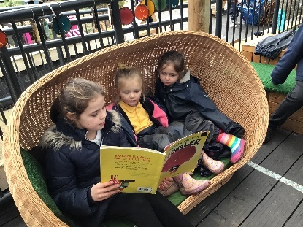 | UNCRC Articles  - Article 20  I have the right to be protected from being hurt or badly treated.  - Article 23  If I have a disability, I have the right to special care and education.  - Article 28  I have the right to an education.  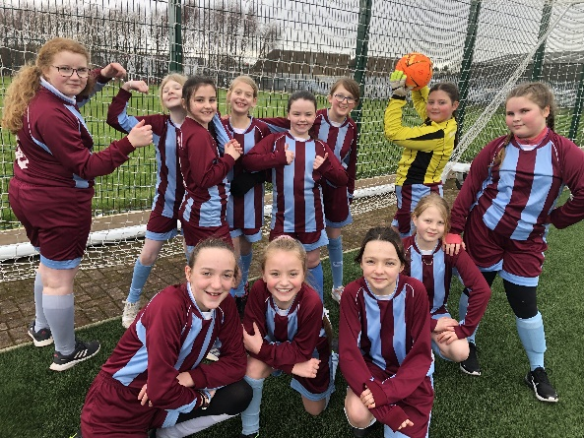 | UNCRC Articles  - Article 29  I have the right to an education which develops my personality, respect for others’ rights and the environment.  - Article 31  I have a right to relax and play.  - Article 39  I have the right to help if I have been hurt, neglected, or badly treated.  - Article 41  Where our country treats us better than the U.N. does, we should keep up the good work!  - Article 42  Everyone should know about the UNCRC.

